 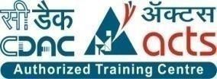

INSTITUTE FOR ADVANCED COMPUTING AND SOFTWARE DEVELOPMENT AKURDI, PUNE

Documentation On

# “E-BUS RESERVATION SYSTEM”

PG-DAC SEP2021

*Submitted By:*

**Group No: 11**

**Ananya Jain (219020) Ashish S. Thube (219033)**

# Centre Coordinator Project Guide:

# Mr. Prashant Karnale Mr.Chetan Pardesi

# Mrs Sneha sakpal

# 

## Table Of Contents

1. Introduction 3

Problem Statement 3

Aim & Objectives 3

1. Overall Description 4

Proposed Methodology 4

Environment 4

Design and Implementation Constraints 5

1. Requirements Specification 6

External Interface Requirements 6

1. System Diagram… 7

Activity Diagram………………………………………………………………………………

Data Flow Diagram……………………………………………………………………………

Class Diagram…………………………………………………………………………………

Use Case Diagram…………………………………………………………………………….

ER Diagram……………………………………………………………………………………

5. Table Structure……………………………………………………………….………………

User

Role

Bus Details

Available Bus Details

Ticket Details

Booked User Detail

Feedback

Future Scope............................................................................................................................

**7. References.................................................................................................................................**

## List Of Figure

Figure 1 User Activity Diagram

Figure 2 Admin Activity Diagram

Figure 3 Level 0 Data Flow Diagram

Figure 4Level 1 Data Flow Diagram

Figure 5 Level 2 Data Flow Diagram for Admin

Figure 8 Class Diagram

Figure 9 Use Case Diagram for User

Figure 10 Use Case Diagram for Admin

Figure 11 ER (MySQL Auto Generated)

Figure 12 ER Diagram

# Introduction.

## Introduction:

E Bus Reservation System is Web based application that works within centralized network. The main purpose of this study is to automate the manual procedures of reserving a bus ticket for any journey made through Any Transport Company. This system is said to be an automatic system and customers can select seats by themselves. Objectives of this project will consist of Providing a web-based bus ticket reservation function where a user can buy bus ticket through the online system without a need to queue up at the counter to purchase a bus ticket. Enabling customers to check the availability and types of busses online. Customer can check the time departure for every bus through the system.

## Problem Statement:

System that are using by staff at the counter currently is an internal system and just used to sell the bus ticket at the counter. Customer has to go to the counter to buy bus ticket or ask for bus schedule. Furthermore, customers need to pay cash when they buy the bus ticket and sometimes needs to queue up long time to get the bus ticket. Besides that, customer also not allowed to buy bus ticket through telephone and the bus company’s telephone always-busy line.

## Aims and Objective:

This product aimed toward a person who don’t want to visit the centre as he might don’t get tine for that or might not interested in visiting there and dealing with lot of formalities.

The new system is totally computerized system. A new system provides features like time efficiency to show bus details, user profiles. This system provides all the ticket booking facility for bus without any Hussle and going outside.

In other words, our System has following objectives: Simple database is maintained.

Easy operations for the operator of the system.

User interfaces are user accommodating and attractive; it takes very less time for the operator to use the system.

# Overall Description.

## Existing System:

The existing Bus Booking System is not completely computerized. The user has to visit any booking branch if he wants to book a ticket. Bus scheduling, ticket booking, bill generation and many other operations are done manually. This may lead to incorrect entries and there is a lot of room for errors as the data is not completely synced. The availability of seats is not centrally maintained and the travel operator is not fully aware of the availability and occupancy of the seats in his buses. This is the major bottle neck problem

## Need For New System:

E-Bus Reservation system is an web application which provides Booking of tickets all over the India. In this application User can view a bus, Bus time, Price, Bus type, Book ticket. It is easy to use. Travel industry is evolving day to day. As the industry evolves the need to digitalize all the transactions becomes need of the hour. This project which will provide the facility to manage bus scheduling and bookings online. Customer can buy ticket over the internet, 24 hours a day, 7 days a week and the bus ticket can’t be lost. The online system let’s the customers check the availability of the bus before they buy bus ticket.

Furthermore, customers no need to pay cash to buy bus ticket because they can pay the bus ticket on the traveling time.

## Benefits For E-BUS Reservation System

* Online booking systems save your staff time. ...
* Removing the bottleneck of phone booking systems. ...
* Greater sales and marketing synergy. ...
* A modern approach to booking. ...
* Increased revenue thanks to upselling. ...
* Can come at a cost. ...
* Requires internet access.

## Technologies Used: ReactJs As Frontend ,SpringBoot as Backend

**Users and Characteristics:**

**Admin:**

Admin can add a bus,add route ,location ,view booking list and also view feedback and enquiry.

**User:**

User can view information of available bus, booking ticket for bus, cancel the ticket and view booked ticket details.

**Features of E-Bus Reservation System.**

**User**

**•View Available Busses:**

. The user can see availability of bus .

**•Booking ticket:**

The user can book the ticket as per as their preferences.

**•Cancel the ticket:**

This system will provide the facility to user to cancel the ticket

**•Give Feedback:**

The user will give the feedback to the admin.

**•Enquiry:**

The inquiry can easily do by user.

**Admin**

•In this section admin can view the details of all bus (Like total bus, total booking, enquiry)

•Admin can create/edit/delete bus details.

• The Admin can add the bus so that the user can see the available buses

• Admin can also edit and delete the bus.

# 3. Requirements Specification.

## Non Functional Requirements:

Following Non-Functional Requirements will be there in the

insurance to the internet:

(i) Secure access to consumer’s confidential data.

(ii) 24X7 availability.

(iii) Better component design to get better performance at peak

time.

(iv) Flexible service based architecture will be highly desirable for

future extension.Non-Functional Requirements define system

properties and constraints.

Various other Non-Functional Requirements are:

➢ Security

➢ Reliability

➢ Maintainability

➢ Portability

➢ Extensibility

➢ Reusability

➢ Compatibility

➢ Resource Utilization

## Performance Requirements:

In order to maintain an acceptable speed at maximum number of uploads allowed from a

particular customer as any number of users can access to the system at any time. Also

connections to the servers will be based on the attributes of the user like his location and serverwill be working 24X7 times.

## Hardware Requirements:

|  |  |
| --- | --- |
| **RAM** | 24GB |
| **Hard disk** | 320 GB |
| **Processor** | I3 |

**Software Requirements**

**Client side:**

|  |  |
| --- | --- |
| **Web Browser** | Google Chrome or any  compatible browser |
| **Operating System** | Windows or any equivalent OS |

**Server side:**

|  |  |
| --- | --- |
| **Web Server** | TOMCAT |
| **Server side Language/front end language** | Spring Boot/ReactJs |
| **Database Server** | MYSQL |
| **Web Browser** | Google Chrome or any  compatible browser |
| **Operating System** | Windows or any equivalent OS |

## External Interface Requirements:

User Interfaces:

User can view information of available bus, Booking ticket for bus, Price, Available seats, Cancel the ticket.

Admin Interface:

Admin can Add Bus, Add Route, Update Bus details, Delete Bus, View Booking List.

Hardware Interfaces:

* No extra hardware interfaces are needs.
* The System will use the standard hardware and data communication resources.

This includes, but not limited to, general network connection at the server/hosting site, network server and network management tools.

Application Interface:

### Web Browser:

The system is a web-based application; client need a modern web browser such as Mozilla Firebox, Internet Explorer, Opera and Chrome. The computer must have an Internet connection in order to be able to access the system.

Communication Interfaces:

The two parties should be connected by LAN or WAN for the communication purpose.

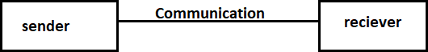

# 

# 4. System Diagrams.

## Activity Diagram:

Admin Activity:

User Activity:

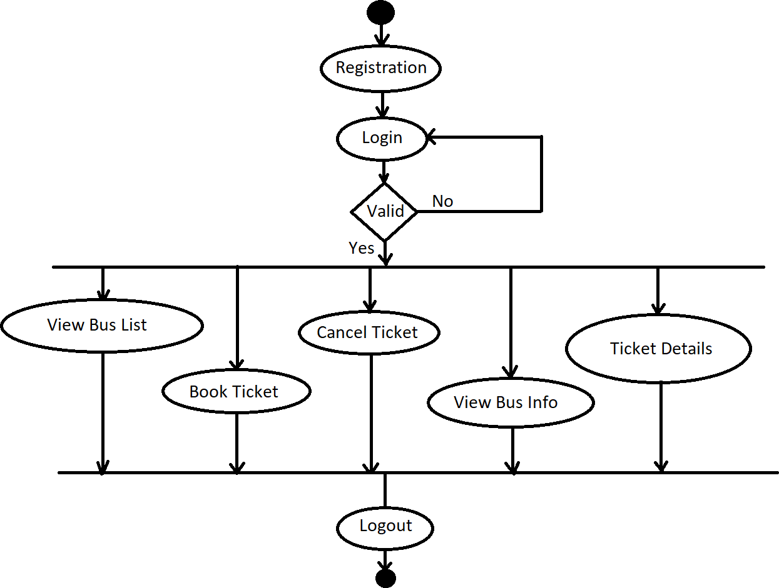

## Data Flow Diagram:

## 

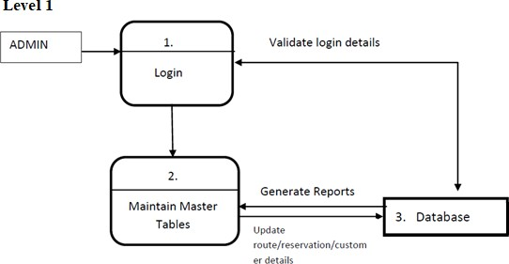

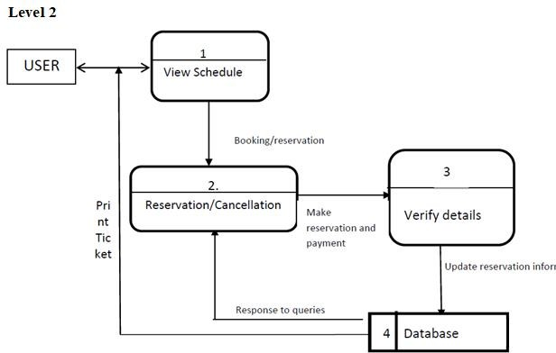

## Use Case Diagram:

User Use-Case:

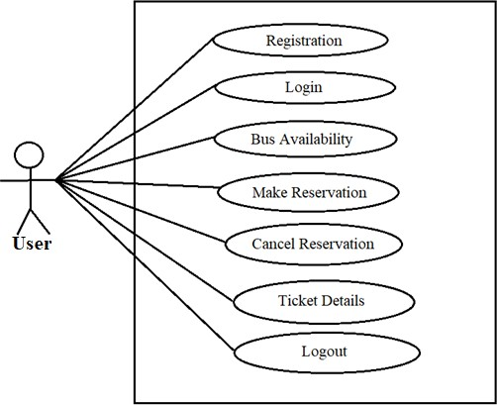

Admin Use-Case:

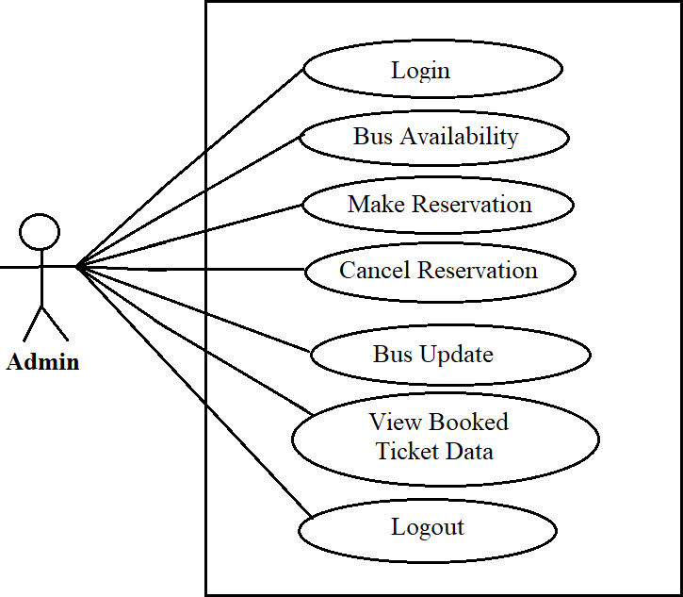

**ER DIAGRAM:**

The Entity-Relationship (ER) model was originally proposed by Peter in 1976 [Chen76] as a way to unify the network and relational database views. Simply stated the ER model is a conceptual data model that views the real world as entities and relationships. A basic component of the model is the Entity-Relationship diagram which is used to visually represent data objects. Since Chen wrote his paper the model has been extended and today it is commonly used for database design for the database designer, the utility of the ER model is:

* It maps well to the relational model. The constructs used in the ER model can easily be transformed into relational tables.
* It is simple and easy to understand with a minimum of training. Therefore, the model can be used by the database designer to communicate the design to the end user.
* 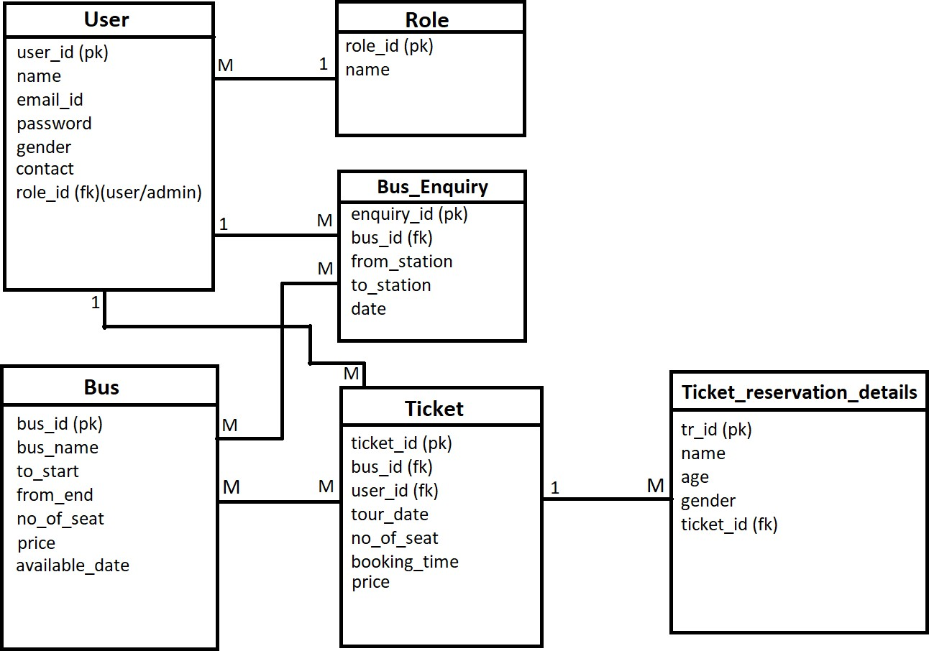In addition, the model can be used as a design plan by the database developer to implement a data model in specific database management software.

5. Table Structure

1. User.

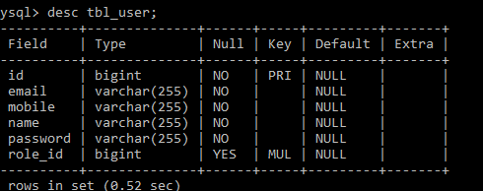

1. Role

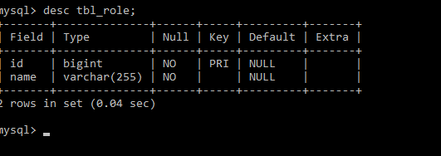

1. Bus Details.

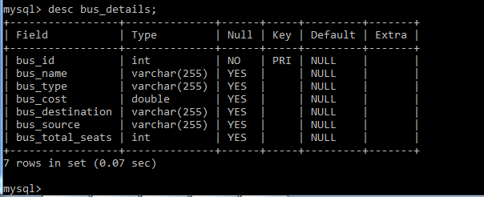

1. Available Bus details

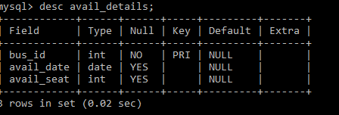

1. Ticket details

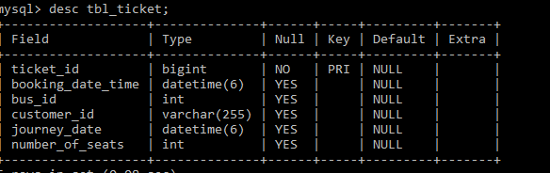

1. User Ticket Details

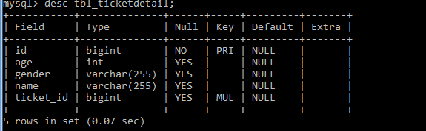

1. Feedback

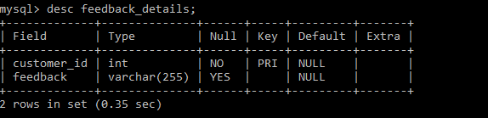

**SCREENSHOT**

**HOME PAGE**

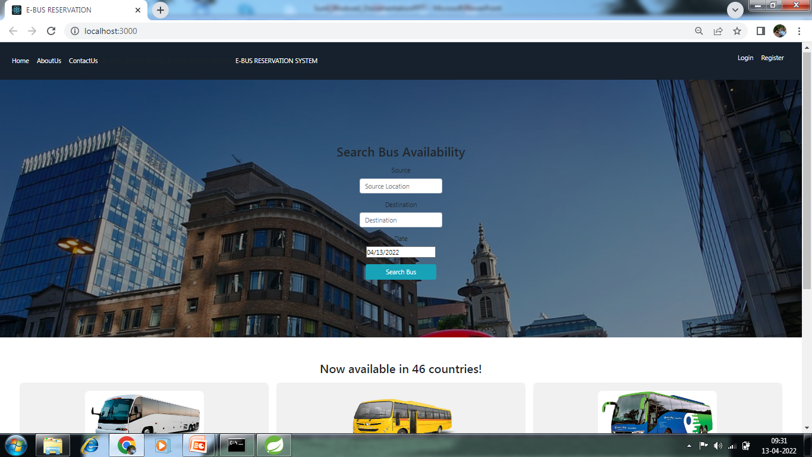

**ABOUT US**

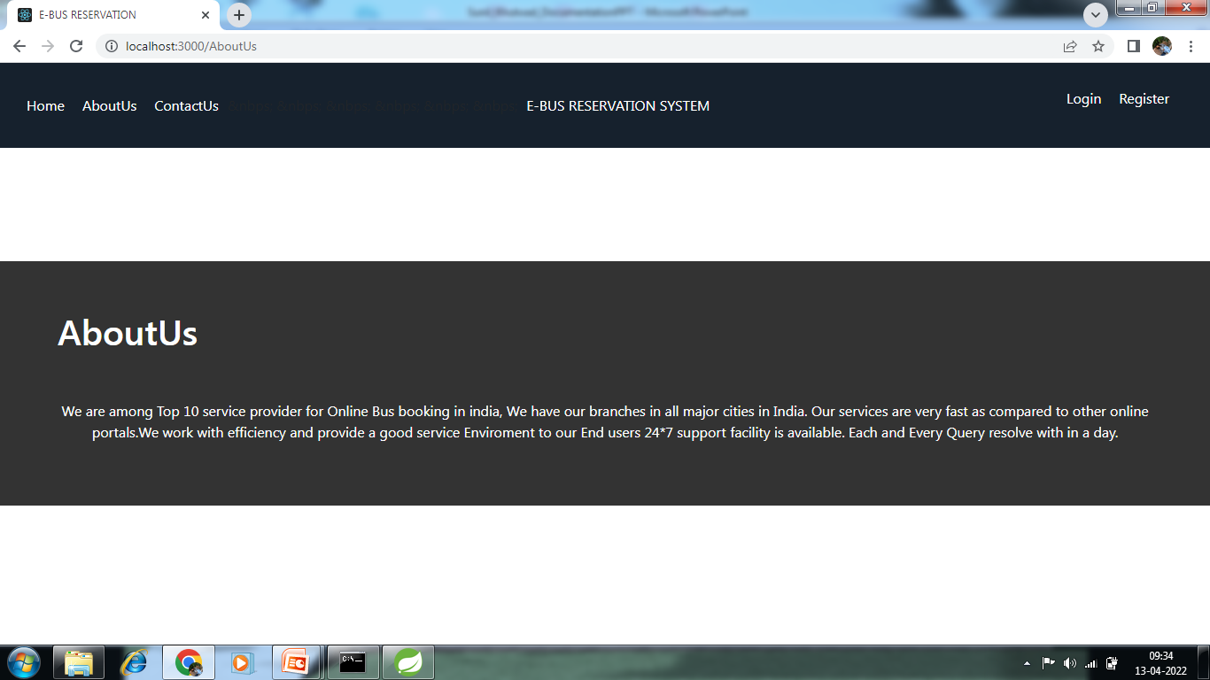

**CONTACT US**

**.**

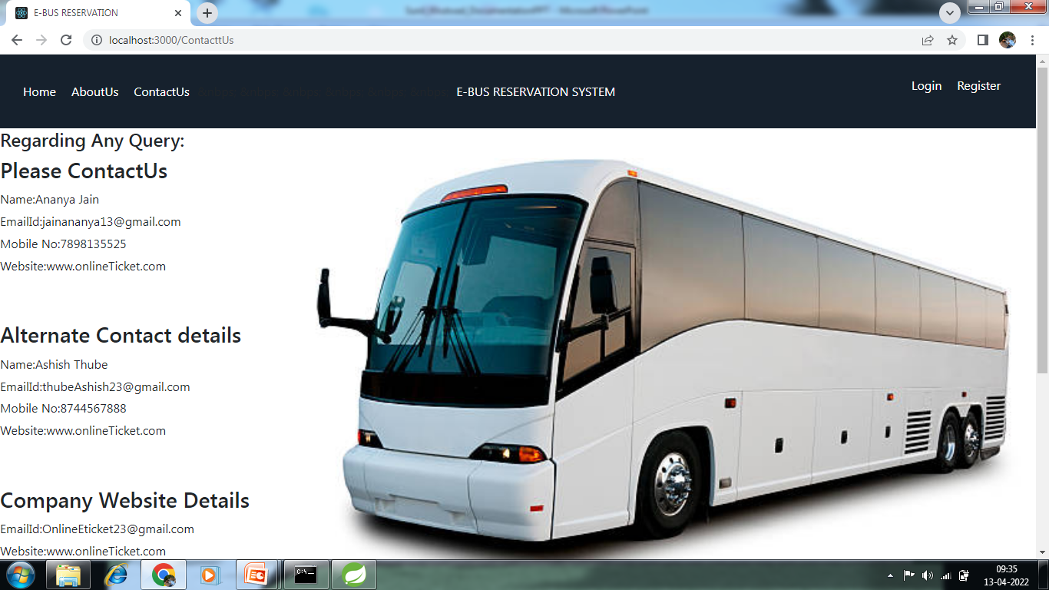

**LOGIN PAGE**

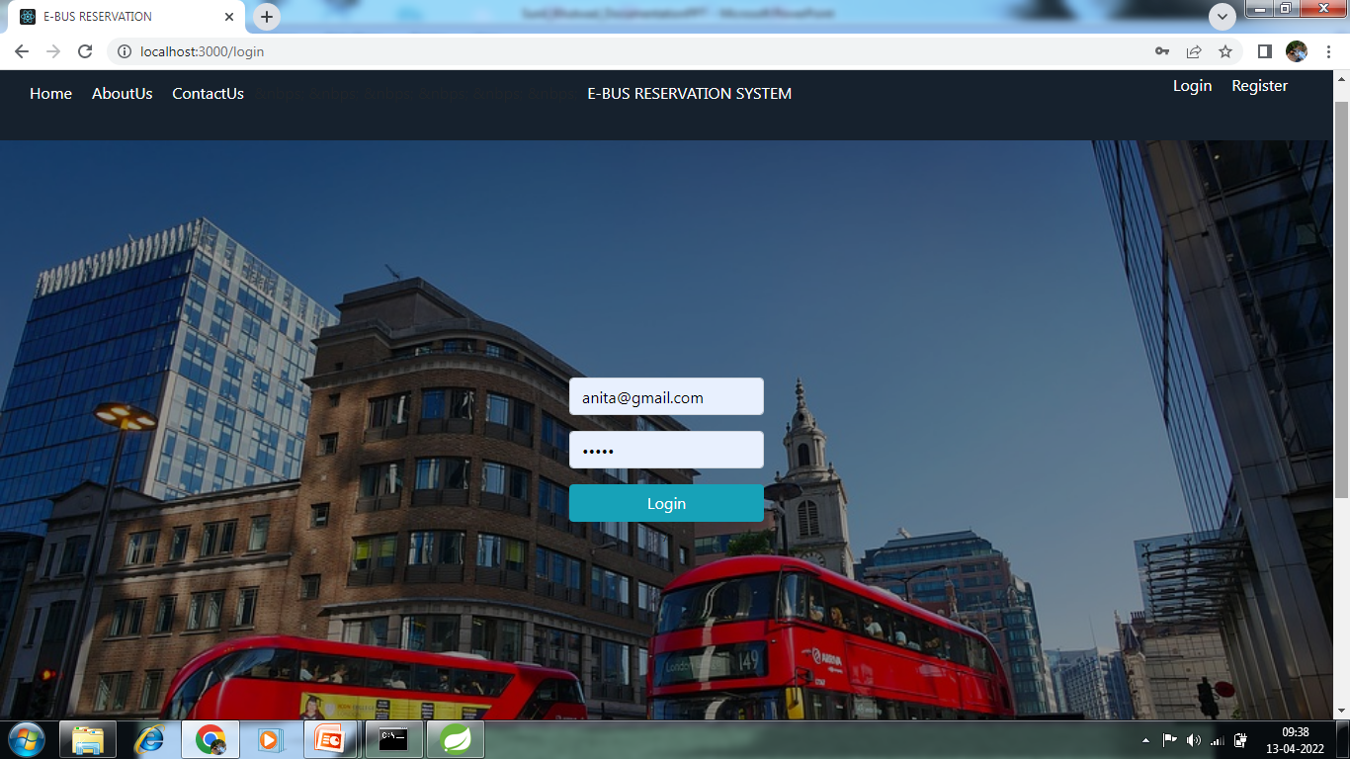

**USER REGISTRATION PAGE**

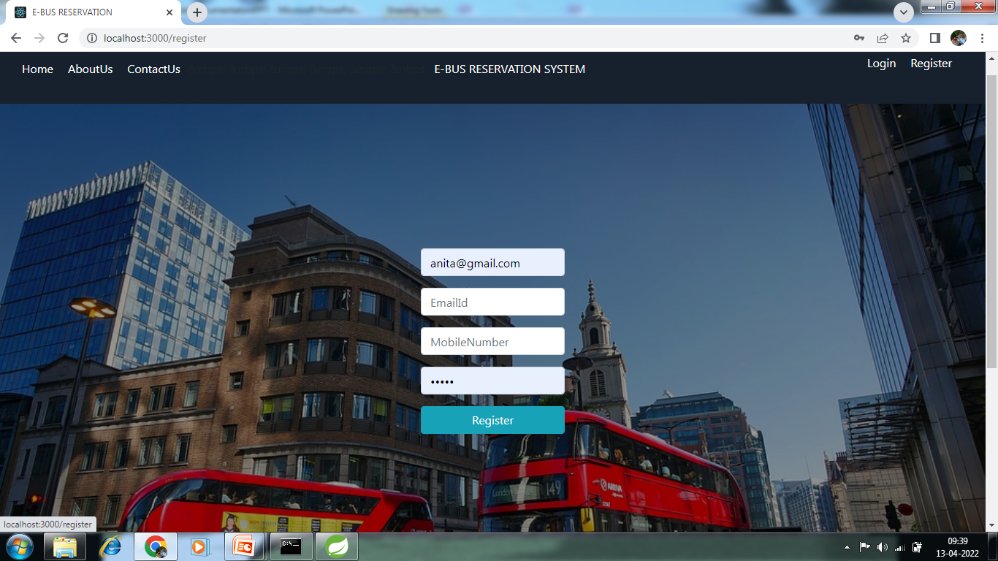

**ADMIN LOGIN**



**FUNTIONALITIES OF ADMIN**

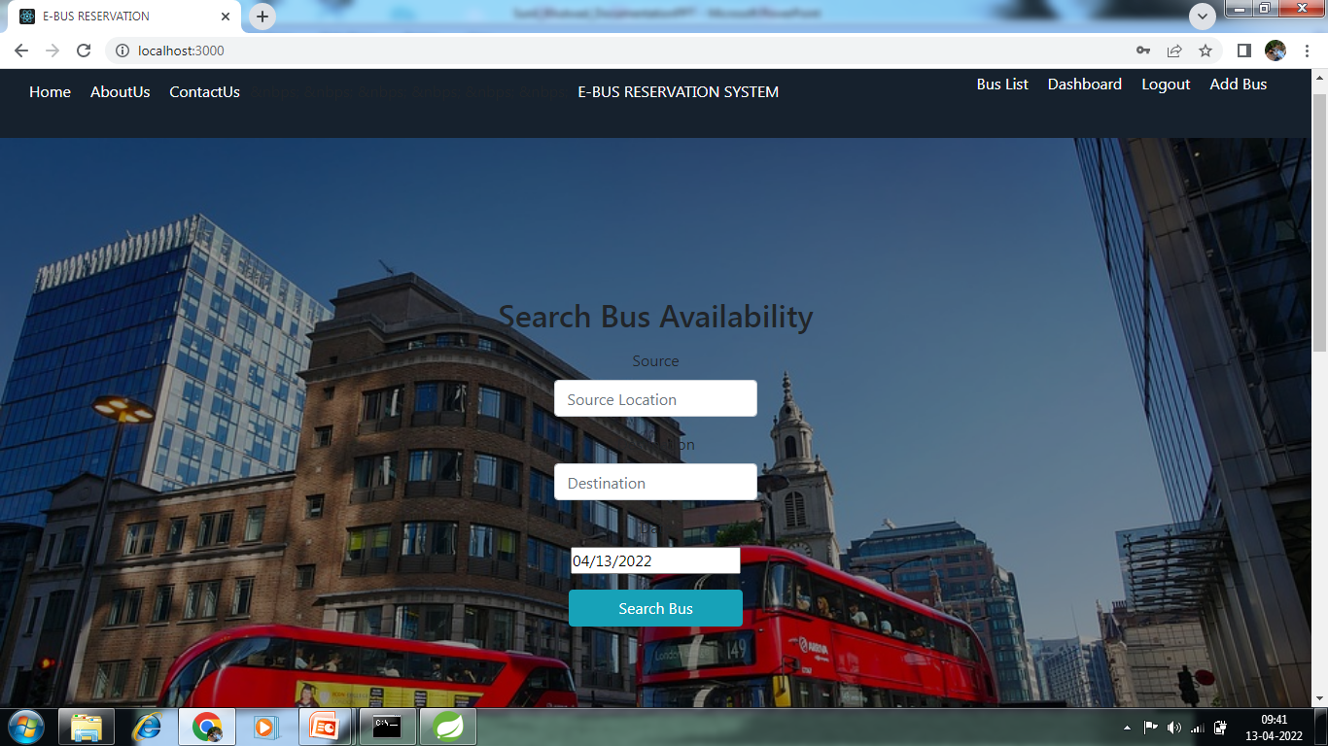

**BUS LIST**

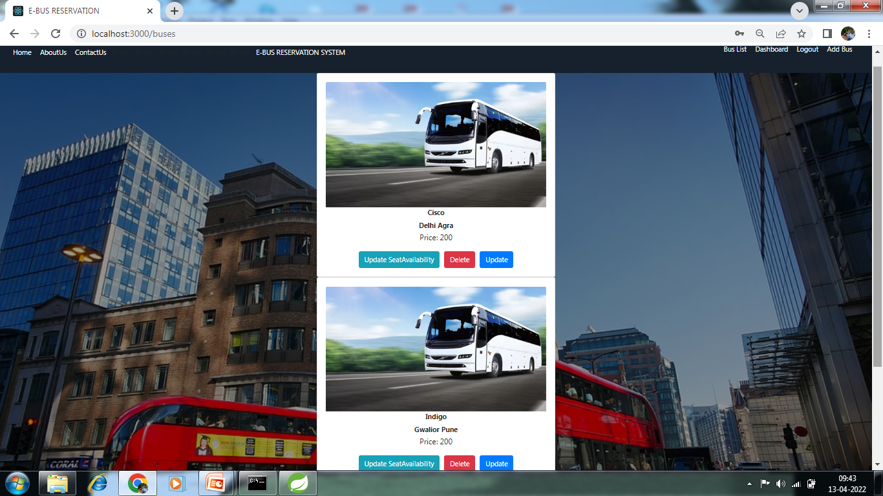

**SEAT AVAILIBILITY**

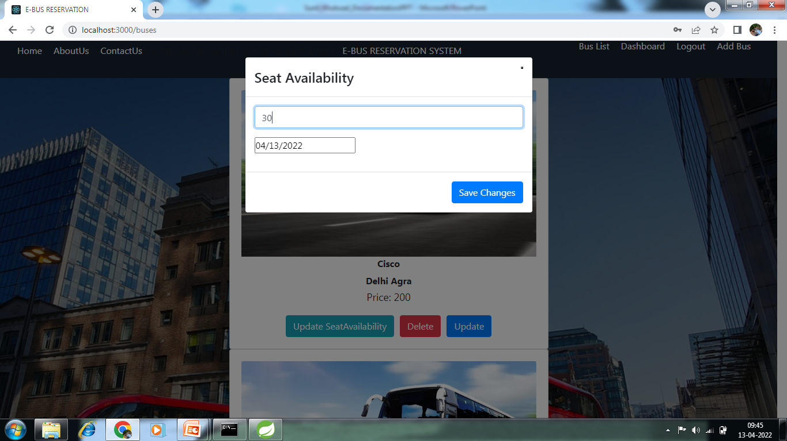

**UPDATE BUS**

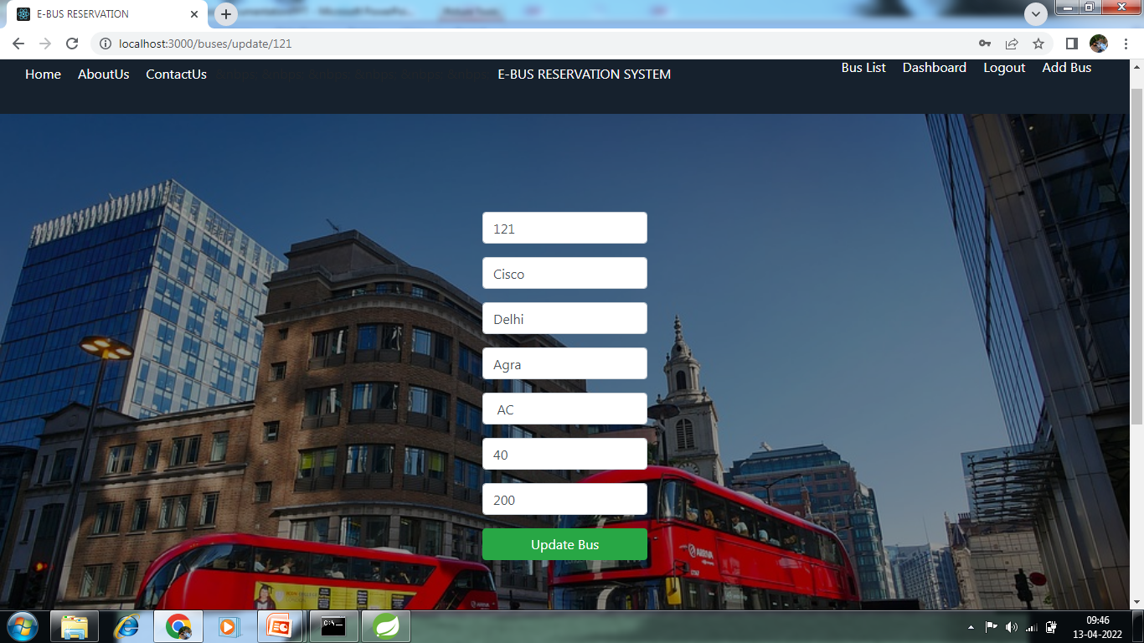

**ADD BUS**

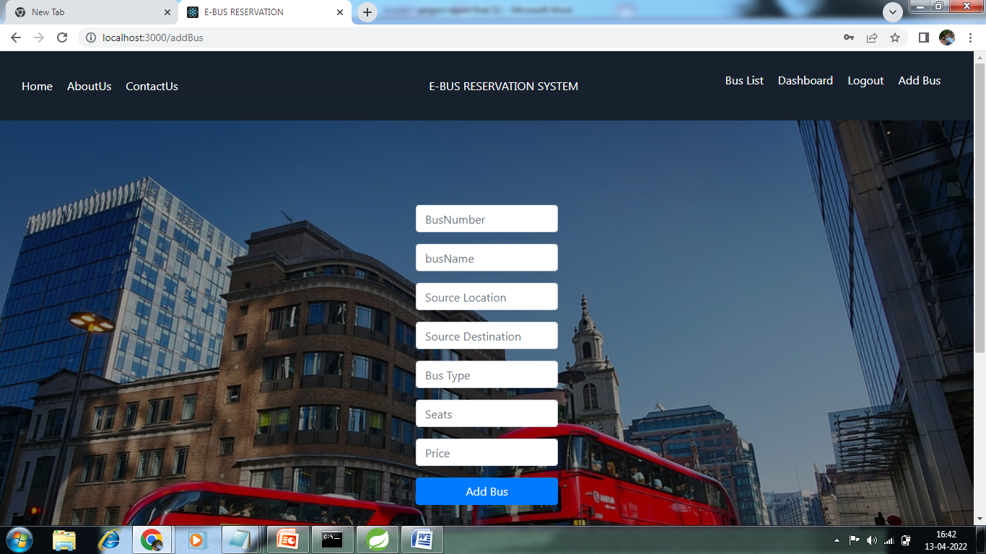

**DASHBOARD**

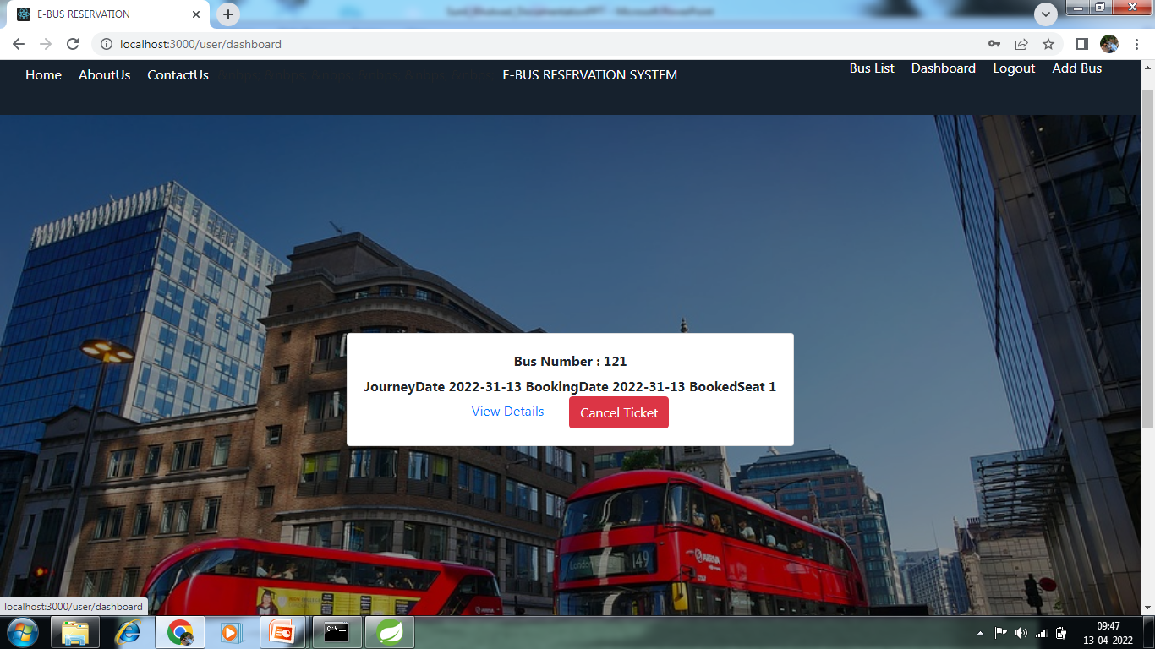

**PASSENGER DETAILS**

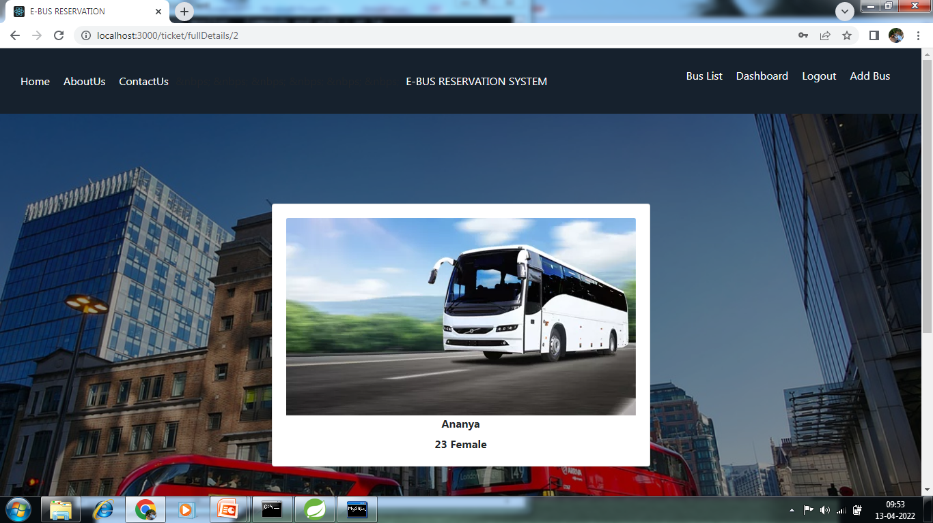

**USER LOGIN PAGE**



**SEARCH BUS AVAILABILITY**

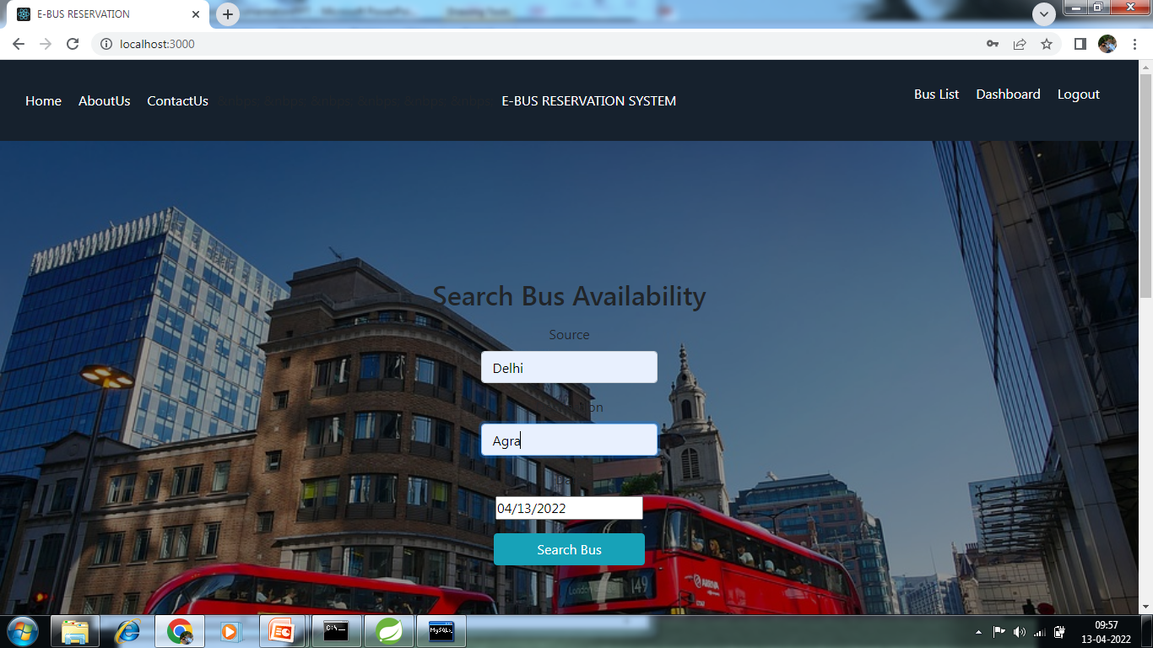

**BOOK TICKET**

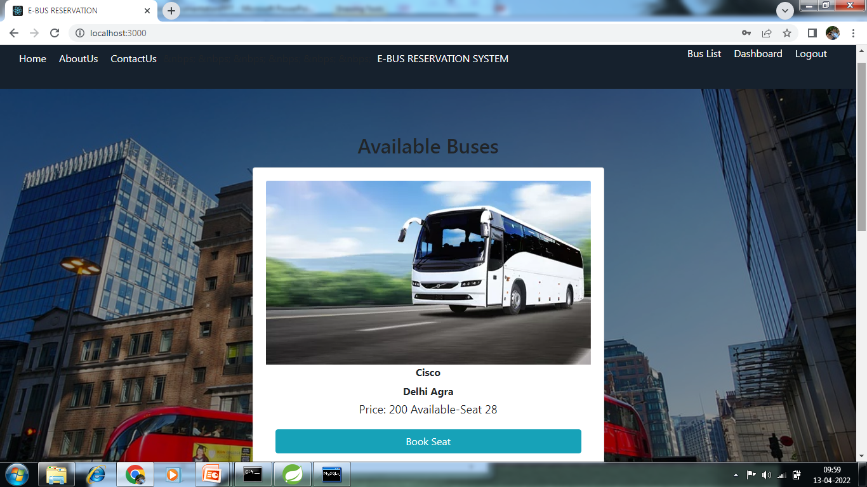

**ENTER DETAILS FOR BOOK TICKET**

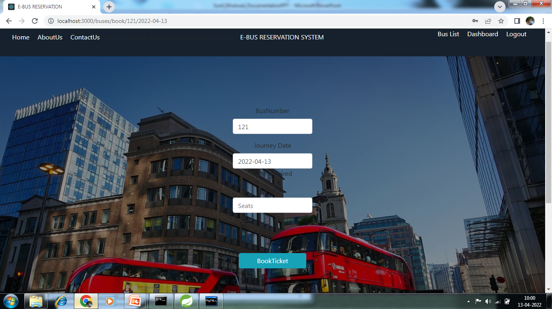

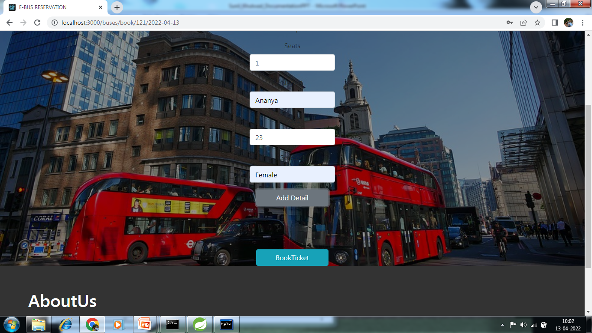

**BUS LIST**

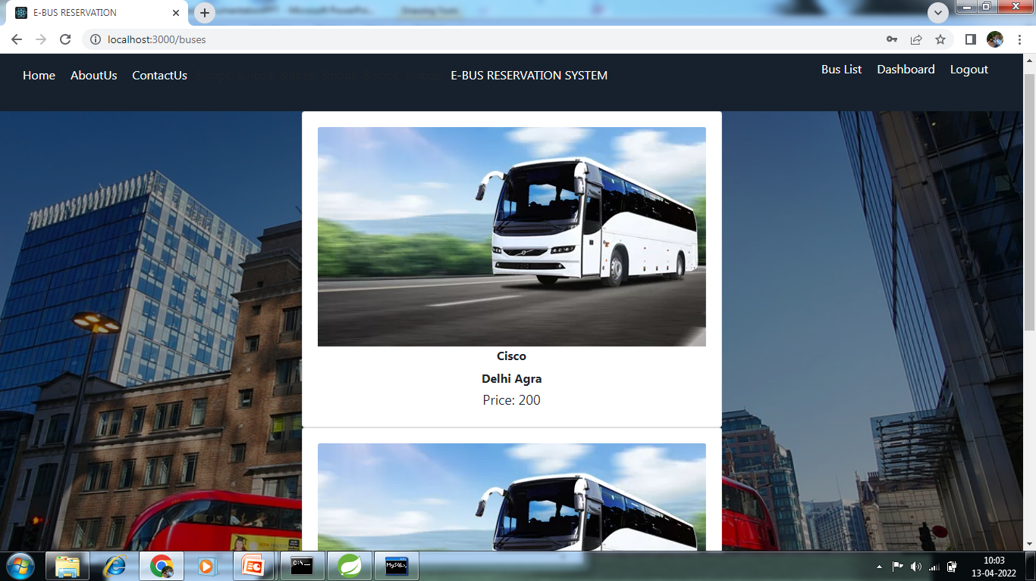

**DASHBOARD**

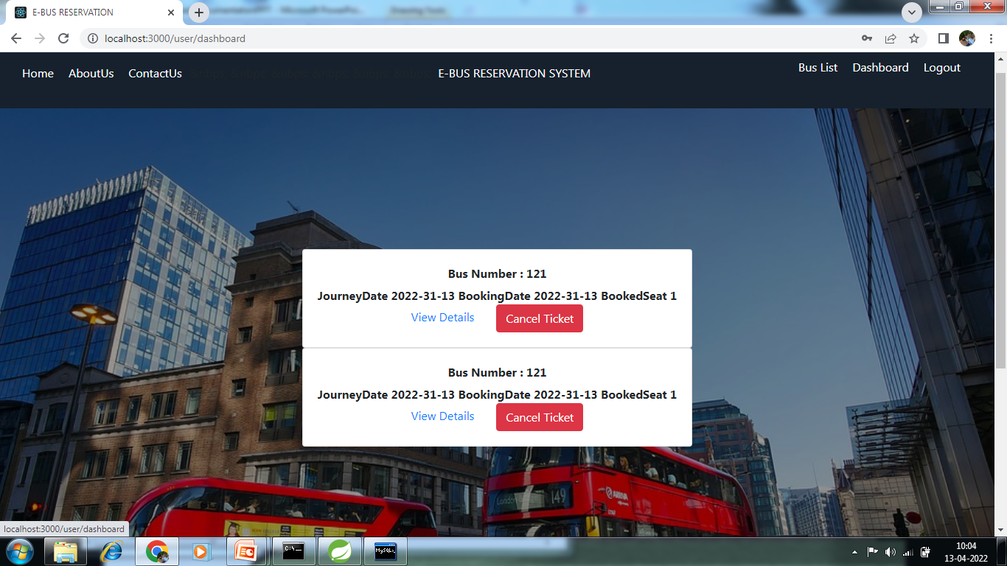

**5. Conclusion.**

It can be observed that computer applications are very important in every field of human endeavor. Here all the information about customer that made reservation can be gotten just by clicking a button with this new system, some of the difficulties encountered with the manual system are overcome. It will also reduce the workload of the staff, reduce the time used for making reservation at the bus terminal and also increase efficiency. The application also has the ability to update records in various files automatically thereby relieving the company’s staff the stress of working from file security of data.

This project, as a whole, will give a new way in bus reservations and ticketing processes. The automation and management of seats and reservations will be done online. However, this project does not limit the walk-in passengers that is passengers who visit the company’s counter because it also caters for them.

This also lessens the use of papers like in the traditional way of ticketing.

**6. Future Scope**

Research and development are continuous processes; this is the same in computer and software development. However, this work is recommended since their operation are still carried out manually and it can also be useful to other Bus Transportation industries whose processes are still manually done. The system can contribute more on those bus representatives handling the account if it can generate reports by trip so that they will no longer go to a certain module to check the reservation and its details. Also, it will be more beneficial to both clients and bus representatives if clients can create an account just like in airlines websites. With that, the system can record the modifications made. Other functionalities such as E-Mail facility for sending Ticket to passenger, Online Payment with Credit Card / Debit Card etc. could also be integrated into the system in order to enhance user friendliness and interactions

**References**

* http://www.ijcstjournal.org/volume-7/issue-1/IJCST-V7I1P4.pdf
* https://bootstrapmade.com/mentor-free-education-bootstrap-theme/
* https://www.javatpoint.com/java-mail-api-tutorial
* https://angular.io/docs
* https://javaee.github.io/javaee-spec/javadocs/
* https://www.w3schools.com/

## 